## **WT - Lab 03**

## **Program to calculate electricity bill in PHP**

Name: Nikita Milind Shitole

PRN: 12011332

Class: CS-TY-D-B2

Roll No.: 16

________________________________________

***.PHP File:***

<!DOCTYPE *html*>

<html>

<head>

    <title>Lab 03: Electricity bill calculator</title>

    <link *rel*="stylesheet" *href*="https://maxcdn.bootstrapcdn.com/bootstrap/4.3.1/css/bootstrap.min.css">

    <script *src*="https://maxcdn.bootstrapcdn.com/bootstrap/4.3.1/js/bootstrap.min.js"></script>

    <style>

        body{

            background: rgb(11, 19, 77);

        }

        .*container*{

            display: flex;

            justify-content: space-between;

            color: white;

            margin-top: 145px;

            padding: 10px 45px 10px 65px;

        }

    </style>

</head>

<body>

    <?php

    $amount = '';

    $kwh_usage = '';

*if* (isset($_POST['submit'])) {

        $units = $_POST['kwh'];

*if* (!empty($units)) {

            $kwh_usage = *calculate_electricity_bill*($units);

            $amount = '<strong>Total amount for ' . $units . ' units -</strong> Rs. ' . $kwh_usage;

        }

    }

    /**

*\* To calculate electricity bill as per unit cost*

*/

    function *calculate_electricity_bill*($units) {

        $first_unit_cost = 8;

        $second_unit_cost = 12;

        $third_unit_cost = 16;

        $fourth_unit_cost = 20;

*if*($units <= 50) {

            $total_bill = $units * 3.50;

        }

*elseif*($units <= 150) {

            $total_bill = 50 * 3.50 + ($units - 50) * 4.00;

        }

*elseif*($units <= 250) {

            $total_bill = 50 * 3.50 + 100 * 4.00 + ($units - 150) * 5.20;

        }

*else* {

            $total_bill = 50 * 3.50 + 100 * 4.00 + 100 * 5.20 + ($units - 250) * 6.50;

        }

*return* number_format((float)$total_bill, 2, '.', '');

    }

    ?>

    <div *class*="container">

        <div *style*="font-size: 30px"><b>Calculate your electricity bill here</b></h1>

            <script *src*="https://unpkg.com/@lottiefiles/lottie-player@latest/dist/lottie-player.js"></script>

            <lottie-player *src*="https://assets3.lottiefiles.com/packages/lf20_7ShNC4.json"  *background*="transparent"  *speed*="1"  *style*="width: 300px; height: 300px;"  *loop*  *autoplay*></lottie-player>

        </div>

        <div *class*="form-group">

            <form *action*="" *method*="post">

            <div *class*="form-group">

                <span *style*="font-size: 30px;">Enter the number of units consumed: <br><br>

                <input *type*="number" *name*="kwh" *placeholder*="Please enter no. of Units" *class*="form-control" /><br>

            </div>

            <div *class*="form-group">

                <input *type*="submit" *name*="submit" *class*="btn btn-primary" *value*="Submit" *style*="margin-left: 209px;" /><br><br><br>

                <div *style*="font-size: 30px; font-weight: 100;">

                <?php echo '<br />' . $amount; ?>

                </div>

            </div>

            </form>

        </div>

    </div>

</body>

</html>

**OUTPUT**

***Electricity bill calculation for 20 units***

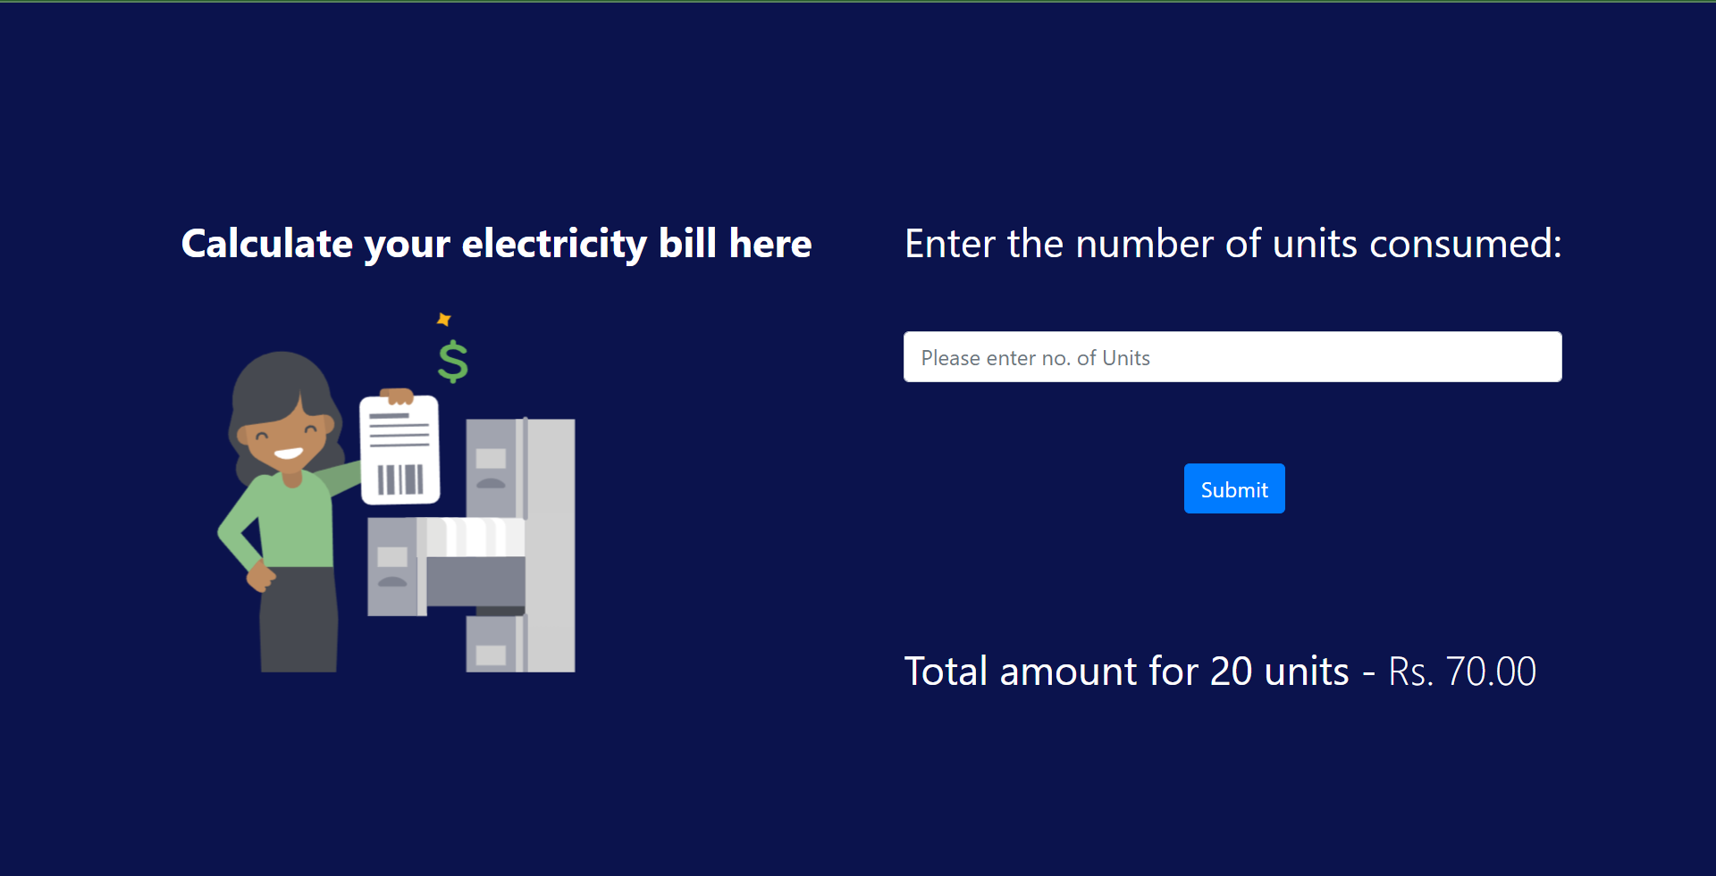

***Electricity bill calculation for 104 units***

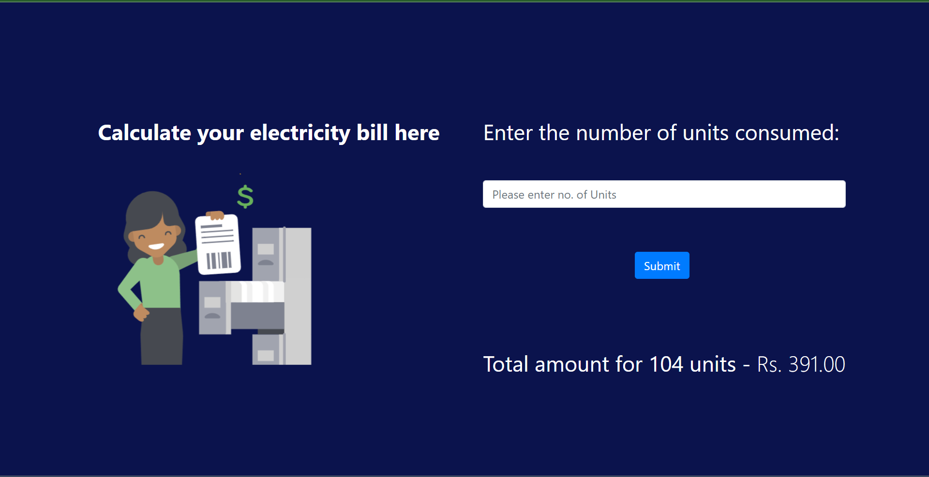

***Electricity bill calculation for 300 units***

